Why wireframes are used:
- Serves as a foundation
- Gives a layout / hierarchy / navigation / user flow
- Clarifies requirements before build
- Supports discussion with stake holders
- Enables rapid iteration and comparison

Fidelity Level | Characteristics | Best Used For
Low | Rough, simple sketches, minimal detail | Early ideas, brainstorming, quick feedback
Mid | Digital wireframes, simple UI, clickable flows | Testing structure, navigation, refining logic
High | Polished visuals, full interaction, realistic | Final testing, stakeholder approval, near-development

Components:
Header (logo, primary navigation)
Hero / Key messaging area
Content sections (cards, panels, lists)
Calls to action (buttons, links)
Forms and inputs
Footer (secondary navigation, legal)

What annotations explain:
- Purpose (What this element enables the user to do)
- Reason (Why you positioned it here)
- User need (Which requirement from the brief it supports)
Examples:
- “Placed here to support quick scanning of destinations”
- “Uses a card layout to allow easy comparison between packages”
- “Primary CTA positioned above the fold to reduce fiction”

Website layout:
F-pattern (Content heavy pages)
Z-Pattern (Marketing / landing pages)
Card-based layouts (travel, products, comparisons)
Single-column vs multi-column layouts (layouts)
Layout Pattern | Best For | Why Use It
F-Pattern | Text-heavy pages | Supports natural reading behaviour
Z-Pattern | Marketing/landing pages | Guides users to a call-to-action
Card-Based | Products, travel, comparisons | Visual scanning and comparison
Single-Column | Reading-focused pages | Mobile friendly, distraction-free
Multi-Column | Data-rich interfaces | More info visible at once

Why card layouts support destination browsing
Users browse destinations based on visual appeal—photos of beaches, cities, landmarks.
Cards naturally highlight imagery, making it easy to scan and compare options quickly.
Cards present digestible chunks of information
Each card bundles key details:
- Destination name
- Image
- Short description
- Rating
- Price or tag
This helps users take in information without feeling overwhelmed.
Cards allow side-by-side comparison
When exploring destinations, people compare visually:
- “This beach looks quiet.”
- “This city seems lively.”
Cards placed in grids support quick, intuitive comparison, unlike lists or text-only layouts.
Cards are flexible and responsive
They adapt well to:
- Mobile
- Tablet
- Desktop
Perfect for travel platforms where people browse on multiple devices.

Why filters and search matter for itinerary planning
Itinerary planning is task-driven, not exploratory
Users often know what they’re looking for:
- “Museums near my hotel”
- “Family-friendly activities”
- “Open on Tuesday”
- “Free things to do”
An itinerary might need:
- Activities that fit a schedule
- Locations near each other
- Weather-friendly alternatives
- Budget constraints
Filters let users narrow thousands of activities to a manageable set, preventing cognitive overload
Search improves efficiency
Instead of browsing endlessly, users can type:
- “Best seafood restaurant”
- “Sunset viewpoint”
- “Kids activities”
This reduces effort and prevents frustration.
Low fidelity wireframe examples
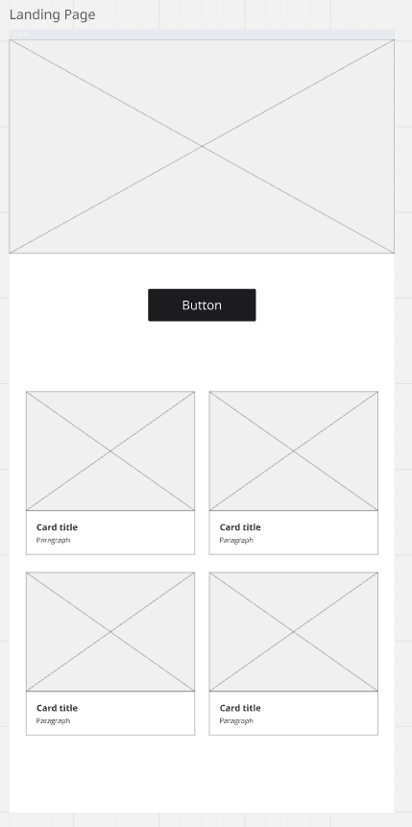
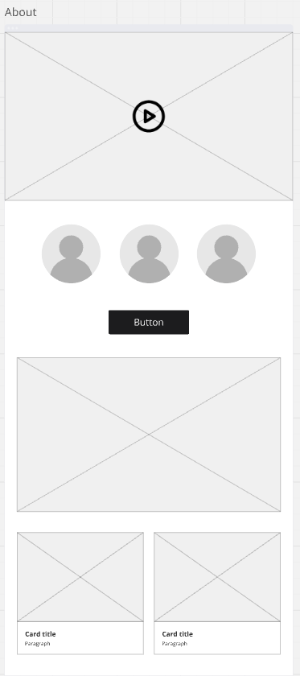
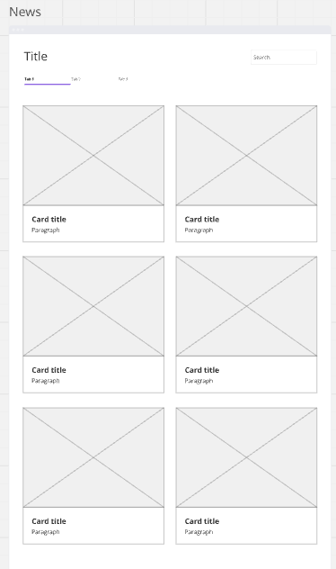
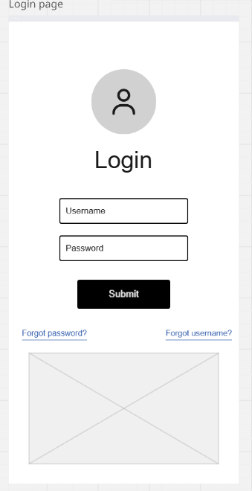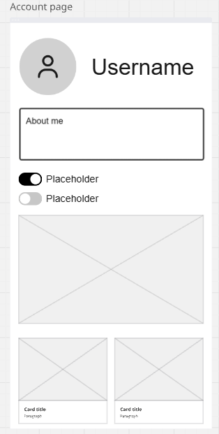

Reflection
The designs showcase wireframes for a website, this is a landing page, about page, news page, login page and account page. Each showing potential low fidelity design ideas for a website.

